Machine Learning in a Week

- Machine learning foundations:
Machine learning now a day all around us whether we are searching a word in a search engine or a Netflix series or a YouTube video or a product on Amazon. Thanks to Machine Learning, millions of cancers can be diagnosed each year, billions of spams and viruses are blocked to protect our computers.
- Uses of Machine Learning:
To better understanding for the Machine Learning and understand how it works we need to understand for what it is used; Machine Learning ML is an application of Artificial Intelligence AI that provides systems the ability to automatically learn and improve from experience without being explicitly programmed.
ML focuses on the development of computer programs that can access data and use it learn for themselves. So basically the uses of the ML based on the programming of an existent information but the ultimate goal is to allow the computers lo learn automatically without human intervention or assistance.
The ML are used in almost everywhere like Voice recognition, virtual assistance, social media services, Email Spam and Malware Filtering, Online Customer Support, Search Engine Result Refining…
- Let the Machine Learn from experience:
ML aim to allow the computer to learn which calculation perform rather than give it this calculation. The inventor of the ML Arthur Samuel developed a program that understand how the checkers is played. Arthur Samuel said: “Machine Learning is the science of getting computers to learn without being explicitly programmed”.
But… How?
To give a computer the capacity of understand we use leaning methods that are strongly inspired by the way humans learn to do things, among these methods there is the Supervised Learning, Unsupervised Learning, Reinforcement Learning, the most commonly is the Supervised Learning methods.
- Supervised Learning:
When you provide many examples to a computer to study here we are talking about supervised learning. The supervised machine learning is the ability to apply what has been learn in the past to new data using labeled examples to predict future events.
To master supervised learning, it’s essential to understand the terms: Dataset, model and parameters, Cost function and Learning algorithm.
- Datasets:

when we talk about datasets, rows and columns are the first things that come to mind like a database table or Excel spreadsheet this traditional structure for data:
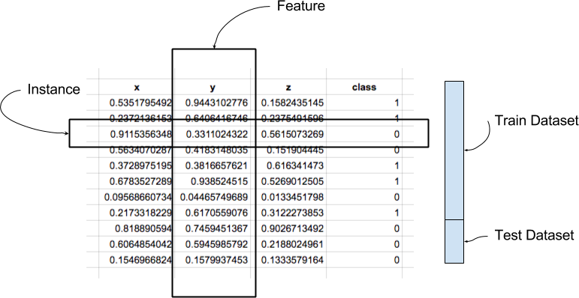
- Instance: a single row of data is called an instance. It is an observation from the domain.
- Feature: features have a data type. They may be real or integer-valued or may have a categorical or ordinal value. You can have strings, dates, times, and more complex types, but typically they are reduced to real or categorical values when working with traditional machine learning methods.
- Datatype: a collection of instances is a dataset and when working with machine learning methods we typically need a few datasets for different purposes.
- Develop a model from dataset:
Using the dataset machine learning could develop a model for this dataset whether a linear model or non-linear model; the linear model is a comparison of two values, usually x and y and the consistent change between the values. The non-linear model is statically technique that helps describe non-linear relationships in experimental data, non-linear model is generally assumed to be parametric where the model is described as non-linear equation.
- Errors of model: Cost Function:
When our model return errors for our dataset these errors are called Cost Function so our aim is to have a good model it’s basically mean a model with fewer errors so a small Cost function. Cost Function are used to estimate how badly models are performing it’s simply a measure of how wrong the model in terms of its ability to estimate the relationship between x et y.
- Learn how to minimize the cost function: Learning algorithm:
To minimize the cost function by finding the parameters of the model to do this we use the learning algorithm which is an algorithm used in machine learning to help the technology to imitate the human learning process. ML uses programmed algorithm that receive and analyze input data to predict output values within an acceptable range as new data is fed to these algorithms they learn and optimize their operations to improve performance, developing intelligence overtime.
- Applications of supervised Learning:
Supervised Learning has been broadly classified in two types: Regression and Classification. Classification separates the data; Regression fits the data.
- Regression: is a technique that aims to reproduce that output value, we can use it to predict the price of some product, like a price of a house in a specific city or the value of stock.
- Classification: is a technique that aims to reproduce class assignments it can predict the response value and the data is separated into classes.

- Other Learning Methods:
As with any method, there are different ways to train machine learning, there are some types of machine learning algorithms that are used in very specific uses-cases, along with the Supervised learning we can use the Unsupervised Learning and Reinforcement Learning.
- Unsupervised Learning:
This algorithm is able to work with unlabeled data, the data collected here has no labels and you are unsure about the outputs. So you model your algorithm such that it can understand patterns from the data and output the required answer. You do not interfere when the algorithm learns.
- Reinforcement Learning:
Directly takes inspiration from how human beings learn from data in their lives. There is no data in this kind of learning, nor do you teach the algorithm anything. You model the algorithm such that it interacts with the environment and if the algorithm does a good job, you reward it, else you punish the algorithm. With continuous interactions and learning, it goes from being bad to being the best that it can for the problem assigned to it.

- Linear Regression:
- Supervised Learning & Regression problem:
Regression analysis is a subfield of supervised machine learning. It aims to model the relationship between a certain number of features and a continuous target variable.
In regression problems we try to come up with a quantitative answer, like predicting the prices of a house or the number of seconds that someone will spend watching a video.
If we are looking to predict the stock market price, the price of an apartment, or the temperature trend on Earth, then you are actually looking to solve a regression problem. If we have a dataset (x, y) then you can use supervised learning to develop a regression model.

- Learn your first Model:
- Collect your data:
Imagine that several real estate agencies provided you with data on apartments for sale, including the price of the apartment (y) and the living area(x), in machine learning it is said that you have m examples of apartments. We design: x (i) the living area of the example I, y (i) the price of the example I by viewing your dataset, you get the following point cloud:
- Create a Linear Model:
From these data, we develop a linear model f(x)= ax + b where a and b are the parameters of the model. A good model gives small errors between its predictions f(x) and the examples (y) of the dataset.
We do not know the values of the values of the parameters a and b, it will be the role of the machine to find them, so as to draw a model that fits well in our point cloud as below:
- Define Cost Function:
For linear regression, we use the Euclidean norm to measure the errors between 𝒇 (𝒙) and (𝒚). Concretely, here is the formula to express the error 𝑖 between the price 𝒚 (𝒊) and the prediction made using the surface 𝒙 (𝒊):
𝑒𝑟𝑟o𝑟 (𝑖) = (𝑓 (𝑥 (𝑖)) - 𝑦 (𝑖)) 2
Each prediction is accompanied by an error, so we have 𝒎 errors. We define the Cost Function 𝑱 (𝒂, 𝒃) as the average of all errors:
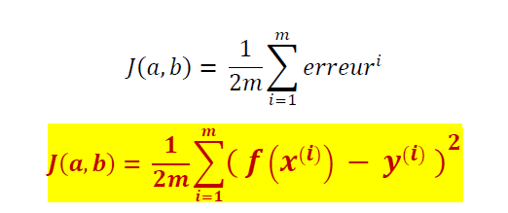
This is the mean squared error:

- Find the parameters that minimize the Cost Function:
The next step is to let the machine learn which parameters minimize the Cost function, that is, the parameters that give us the best model. To find the minimum, use an optimization algorithm called Gradient Descent.
- Gradient Descent: is an optimization algorithm used to minimize some function by iteratively moving in the direction of steepest descent as defined by the negative of the gradient. In machine learning, we use gradient descent to update the parameters of our model.

- Steps to develop a Linear Regression program:
It consists of 3 stages – (1) analyzing the correlation and directionality of the data, (2) estimating the model, i.e., fitting the line, and (3) evaluating the validity and usefulness of the model. First, a scatter plot should be used to analyze the data and check for directionality and correlation of data
- Goodbye Excel, Hello Python, here you are Data Scientist:
- Installing Python anaconda: the best Machine Learning Tool:


Anaconda (Python distribution) Anaconda is a free and open-source distribution of the Python and R programming languages for scientific computing (data science, machine learning applications, large-scale data processing, predictive analytics, etc.), that aims to simplify package management and deployment.
Anaconda contains all the tools and libraries you need to Machine Learning: Numpy, Matplotlib, Sklearn…
- First step go to the anaconda python page and download the version suitable for your computer https://www.anaconda.com/products/individual

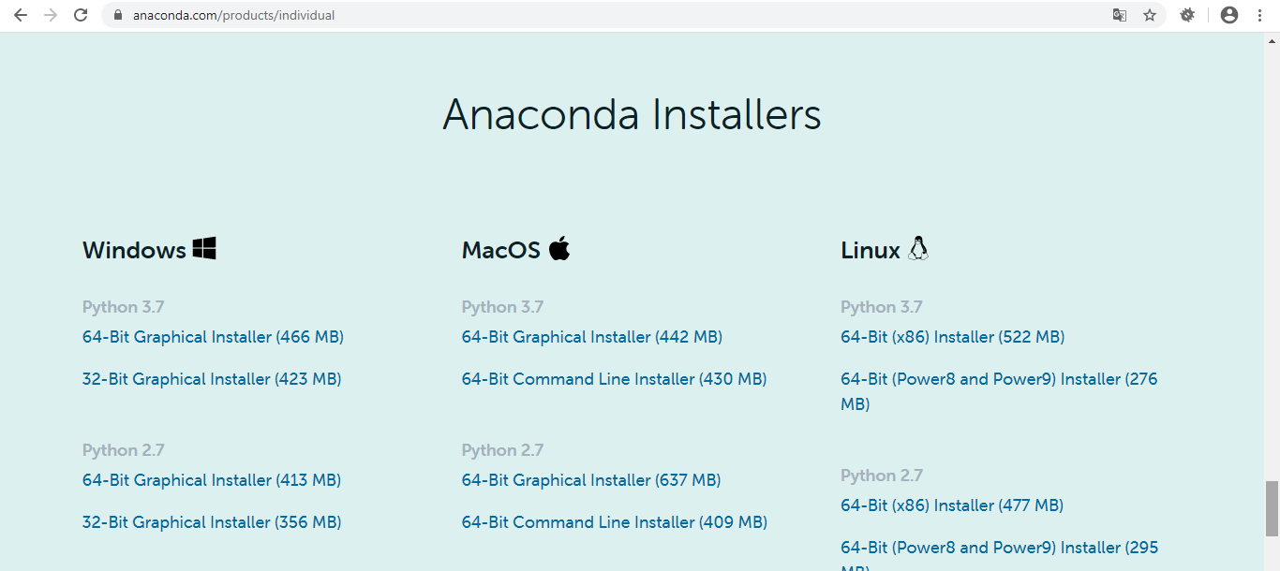

- After downloading and installing Anaconda in the start icon in your machine search for Jupyter Notebook

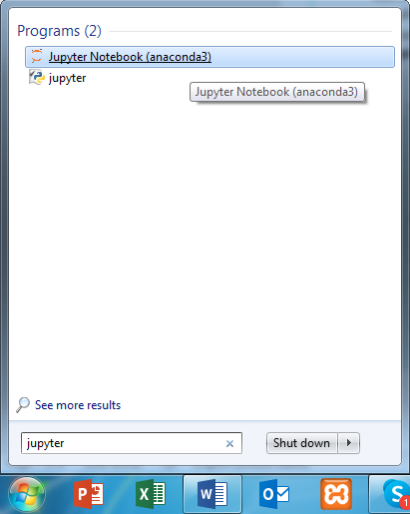
- Using Jupyter Notebook for your projects: Jupyter Notebook is a web application that allows you to create and share Python codes.
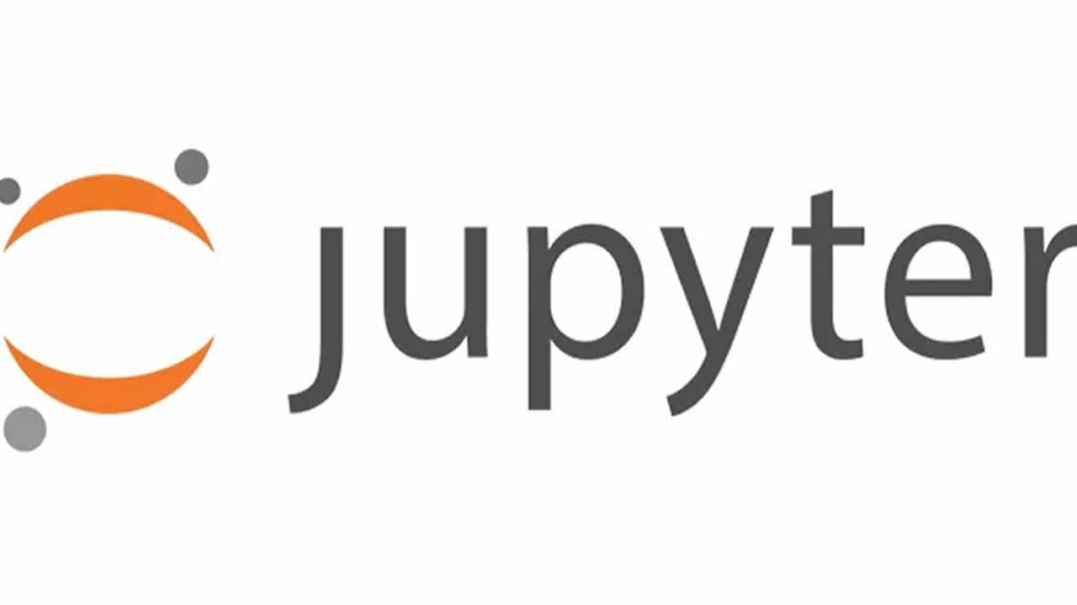
It’s a web application, but you don’t need to have an Internet connection to use Jupyter. Also, your data / codes are never stored on the Internet (it’s not from the Cloud).
- Open Jupyter will open two windows usually you don’t occupy with the black window, the console window, and especially do not close it, this would disconnect Jupyter from your hard drive. The second one is where you are going to work with all your tools and all.

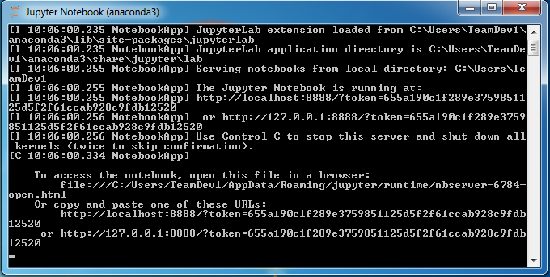
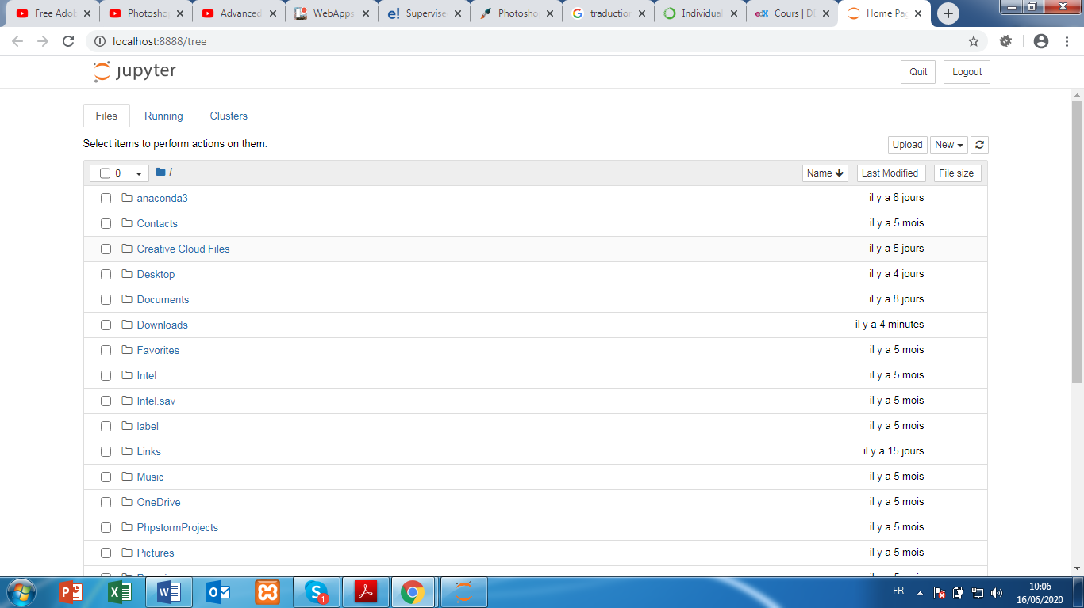
- To open a file to work with click on the New button and choose Python 3.
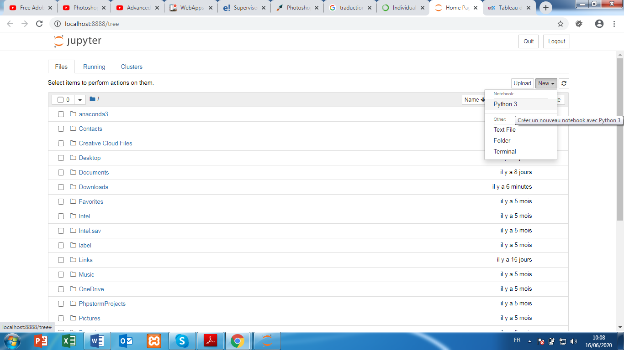
- The following window is displayed: You are ready to code!

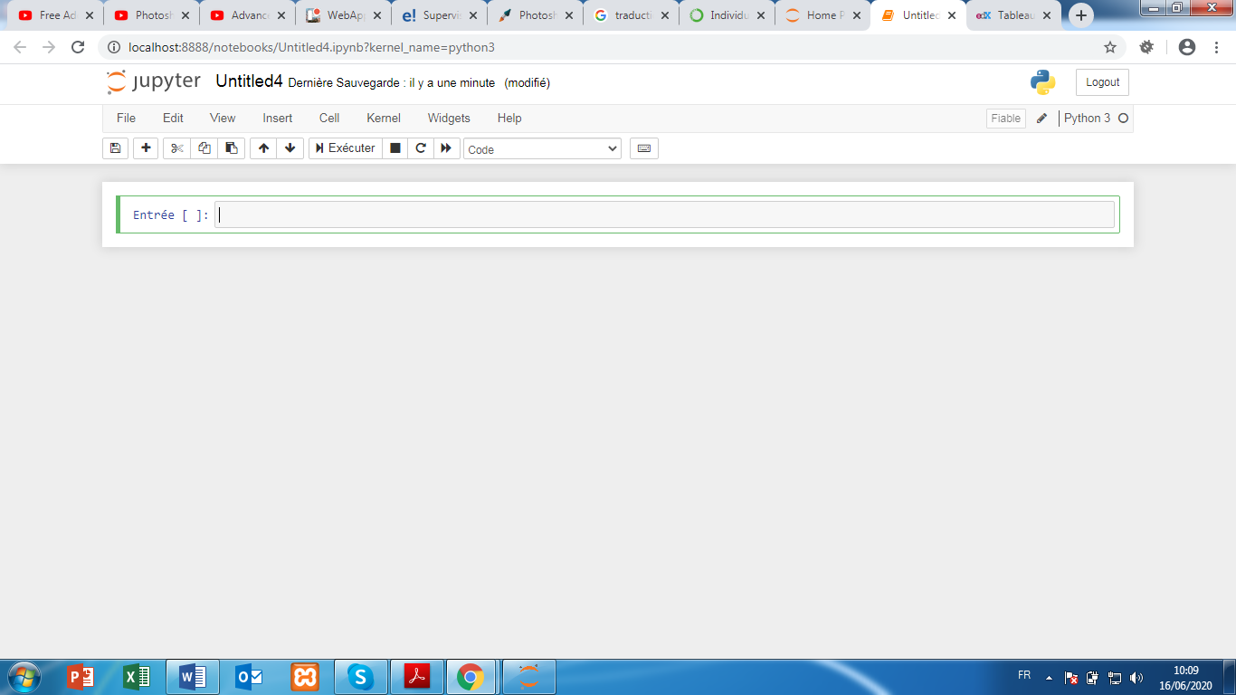
- Learn programming in 15 minutes:
Programming: a new vision of the world
In programming, we choose to adopt a certain vision of the world in which we live. We can consider that the world can be modeled from 2 concepts:
- Items
- Actions, which modify the state of objects.
when we express ourselves, it is necessary and sufficient to say a name (object) and a verb (action) to make a sentence.
Most often, there is no need to develop your own functions because these are already developed in open libraries source. For example, the Sklearn library contains all the functions math and the gradient descent algorithm that we have. In practice, it is therefore unnecessary to write the least mathematical equation.
- PYTHON basics:
- Comments:
In any programming language, it is possible to write comments. A comment is not read by the machine, so you can write whatever you want to document your code.
In Python, just precede your code with the symbol “#” for the transformer as a comment.
# this is a Comment!
- Variables:
To define a variable in Jupyter, simply give it a name and assign it a value. For example, you can choose to create the variable “speed” and assign it the value 90. You can perform mathematical operations between numeric variables.
Once the code is written, displayed on CTRL + Enter to execute your code. The result is displayed and a new cell opens at the bottom to continue writing code.
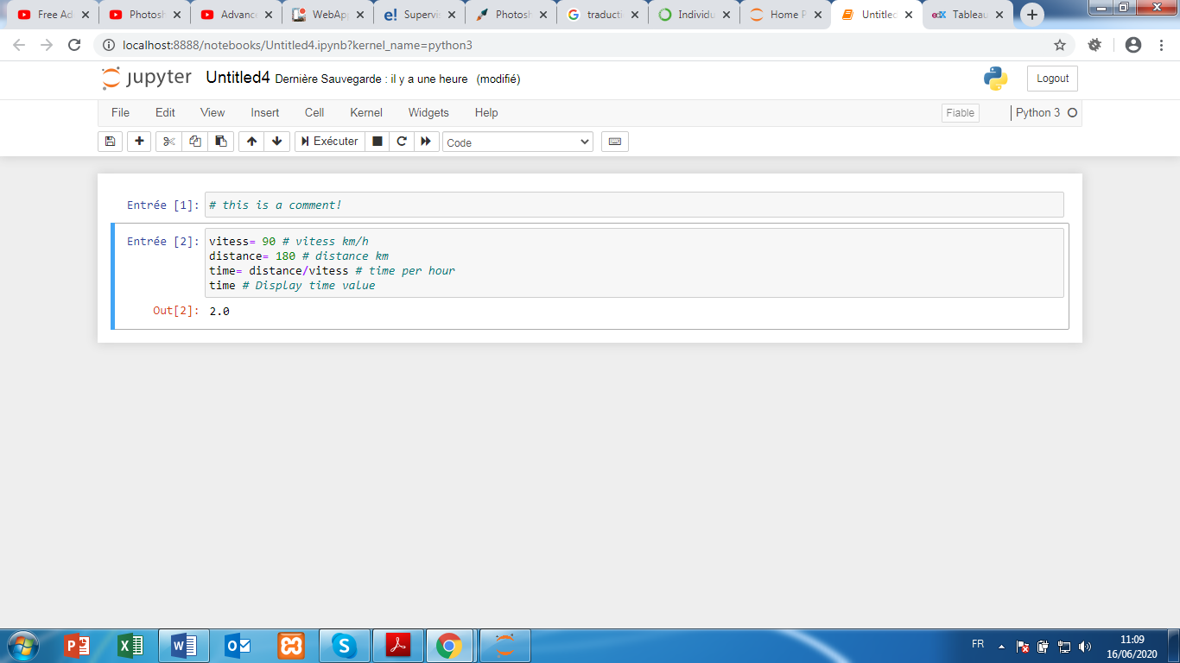
There are many types of variables: numeric variables, lists, matrices, strings, etc.
- Functions:
As stated above, Python already contains many libraries filled with very useful functions and there is no need to code its own functions for machine learning.
To create a function in Python, you must first write "Def" at the beginning of the line, then give a name to the function, write the entries in parentheses, and end the line with a ":".
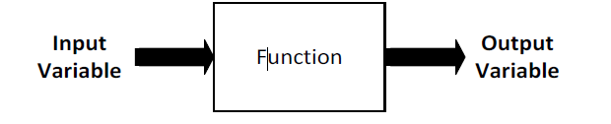
The following lines are part of the function, you can write comments, create new variables, do operations math…
The function stops at the "return" line which indicates which output the function must produce. Once the function has been created, you can use it forever!
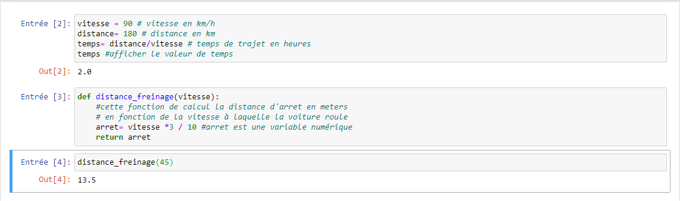
- The 4 libraries to master for Machine Learning:
To import a library in Python, nothing could be simpler. Just write the name of the library preceded by "import" at the top of your program. It is also possible to import certain library functions by writing from "library" import "stuff"
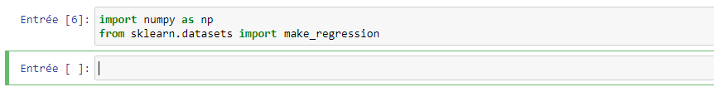

Numpy is a library that allows you to create and manipulate matrices simply and efficiently.
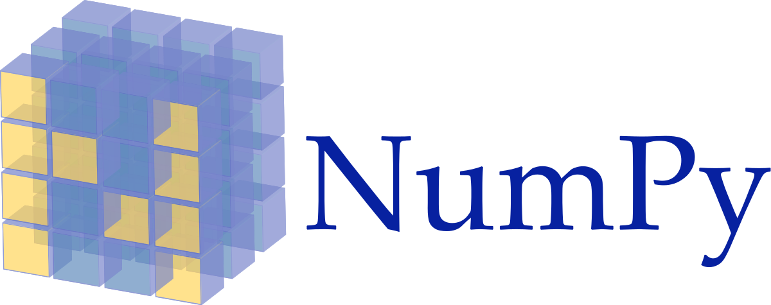
In Machine Learning, most often we insert our Dataset into matrices. Thus matrix calculation represents the essential of Machine Learning. It is important to understand, but the functions present in Numpy do the matrix calculations for us.

Matplotlib is the library which allows us to view our Datasets, our functions, our results in the form of graphs, curves and point clouds.
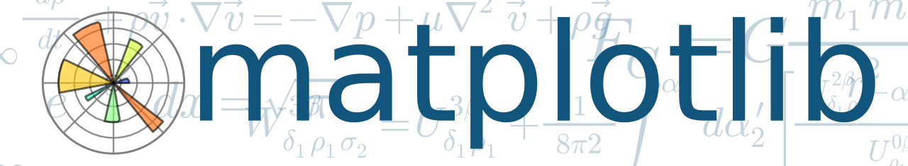

Sklearn is the library that contains all the state-of-the-art features of Machine Learning. It contains the most important algorithms as well as various preprocessing functions.
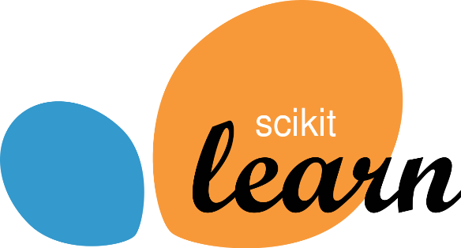

Pandas is an excellent library for importing your Excel tables (and other formats) into Python in order to get statistics and load your Dataset in Sklearn.
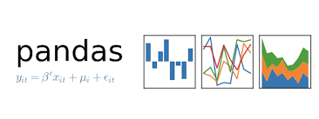
Finally develop your first Machine Learning program:
Here are the steps for develop a linear regression model:
- Step1: Import library: Open a new page from your Jupyter Notebook an import the following libraries:
- Numpy to manipulate our Dataset as a matrix
- Matplotlib.pyplot to view our data
- Sklearn make_regression function to generate a point cloud
- SGDRegressor (which stands for Regressor Stochastic Gradient Descent Regressor) and which contains the calculation of the Cost function, gradients, the minimization algorithm, in short… everything that might seem complicated in chapter 2.
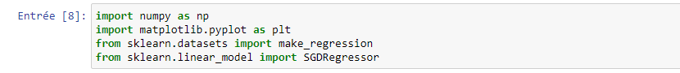
- Step2: Create a Dataset: For this first code, we will not import personal data. Rather, we will generate an array of random (𝒙, 𝒚) data.
For this, the make_regression function is very useful. The function takes as arguments the number of samples to generate, the number of variables and the noise then returns two vectors 𝒙 and 𝒚.
To control the randomness, write the line np.random.seed (0).
Finally, to visualize our data on using the plt.scatter (x, y) function.
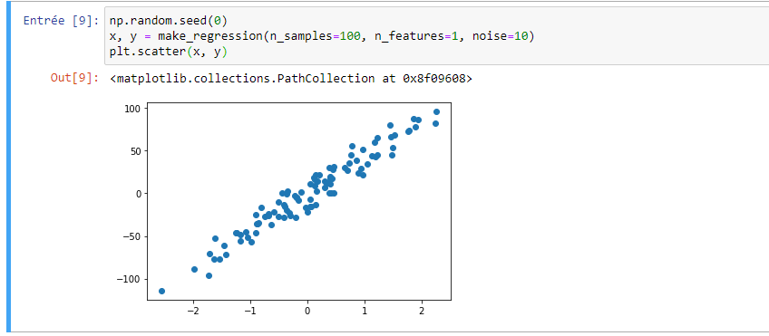
- Step3: Develop & train the model: To develop and train a model, there is a lot of mathematics: Between the Cost Function, the derivatives, the Gradient Descent algorithm…
Sklearn already has it all, you just need to define a variable model from the SGDRegressor generator by entering the number of iterations that the Gradient Descent must perform as well as the Learning Rate. Once the model is defined, you need to train it. To do this, just use the fit function.
For example, let's train our model on 100 iterations with a Learning rate of 0.0001:
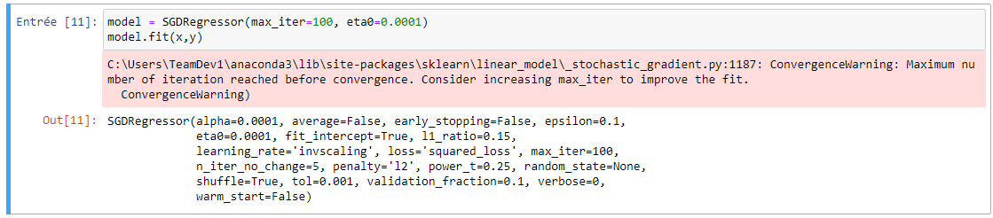

We can now observe the precision of our model using the score function which calculates the coefficient of determination between the model and the values ​​of our data set. We can also use our model to make new predictions with the predict function and plot these results with the plt.plot function:
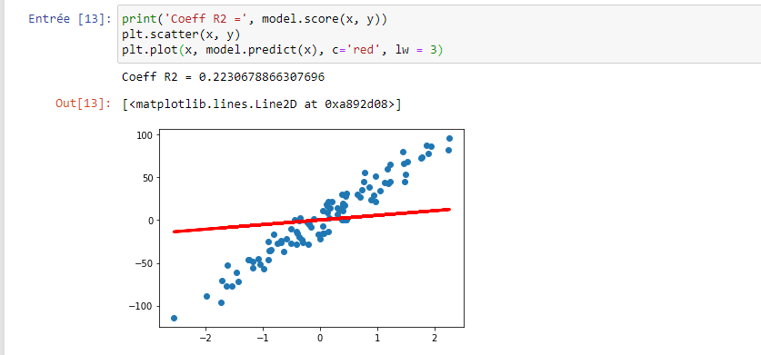

Our model looks really bad. It’s because we didn’t train it long enough and the learning rate was too low. No problem, it is possible to re-train with better hyper-parameters.
You can use the following values ​​that have been good for most workouts:
• Number of iterations = 1000
• Learning rate = 0.001

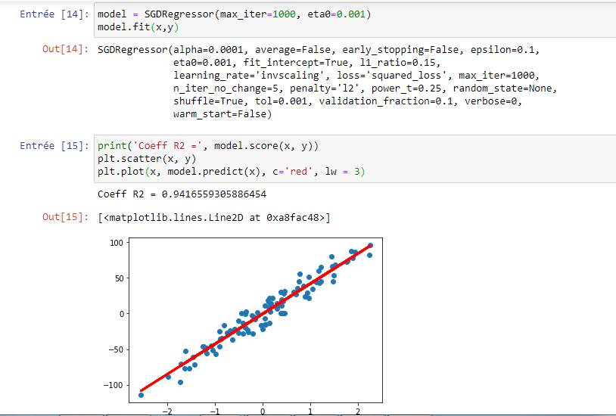
machine learning has specific parameters of the model with the Gradient Descent. For this, there are what are called learning curves.
- Learning Curves:
In Machine Learning, on the learning curve the curves that indicate the evolution of the Cost function over the iterations of the descent of the gradient. If your model is learning, then its Cost function should decrease over time
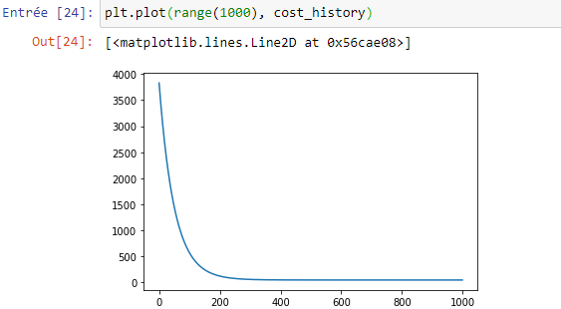

- Multivariate polynomial regression:
For the polynomial of second degree it allows us to draw a non-linear curve, so the cost function will be more complex to calculate since we have 3 parameters so the gradient will be complicated too since we have to calculate 3 gradients so the descent gradient will be complex too.
So to solve this problem that it can be overwhelming in case a 10-degree polynomial, we have to convert the equations into matrix forms: thanks to this matrix we will create a model f(x)= ax²+bx+c under a matrix form f=x. Ɵ.
Using the linear regression, we have used before to develop a non-linear model much more complex, it should just generate polynomials values in our dataset using the function polynomialFeatures in the Sklearn.
Thanks to the matrix calculation in Numpy and Sklearn the machine can integrate this new polynomials values without changing the calculation.
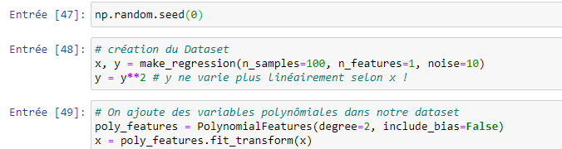
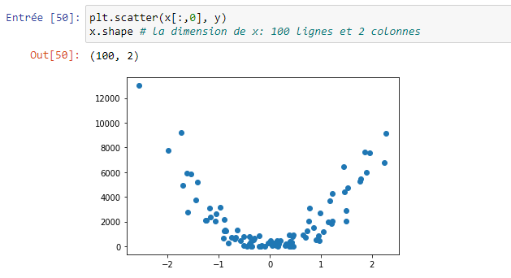
- Train the model again:
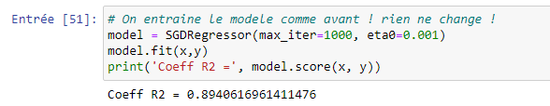
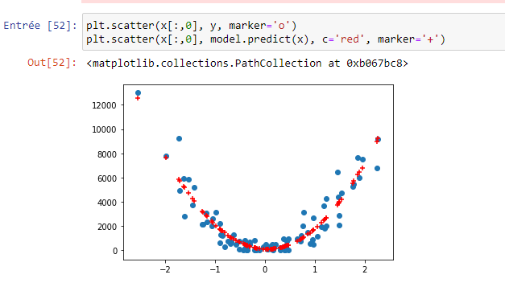
- The first step in machine learning is to download and install Anaconda Python which contains a dozens of necessary libraries like Jupyter, Numpy, Sklearn…
- With sklearn you can get easily the regression model and the polynomial model using the following functions:
- model=SGDRegressor (nb_iterations, learning_rate)
- model.fit ( x, y): to train the model
- model.score(x,y): Evaluate the model
- model.predict(x): generate predictions

- Develop your first Machine Learning program:
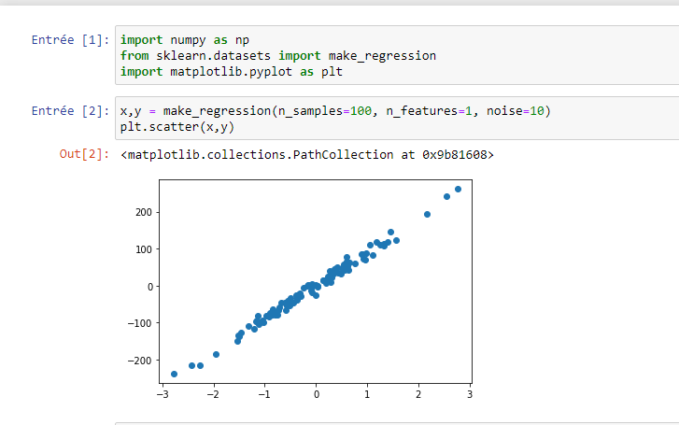
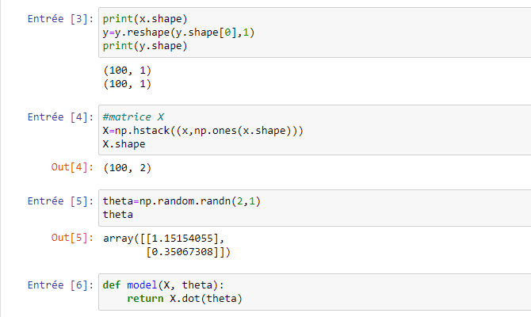
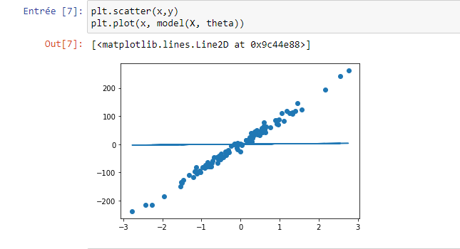
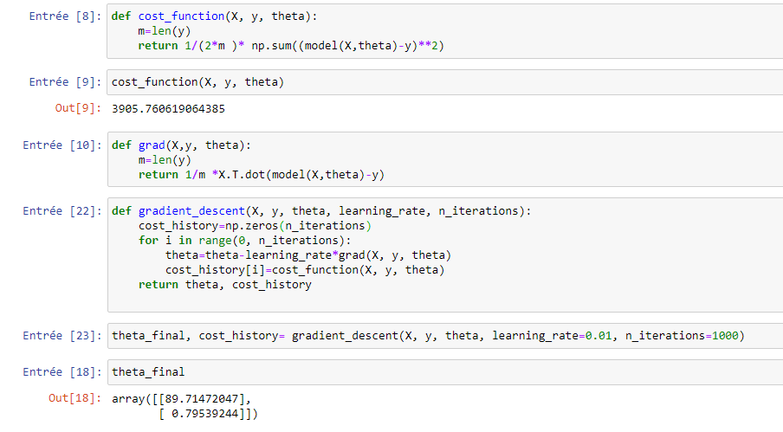
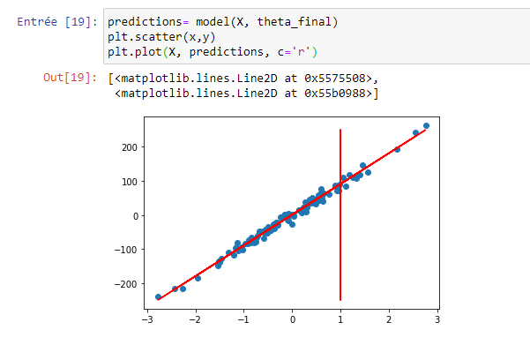
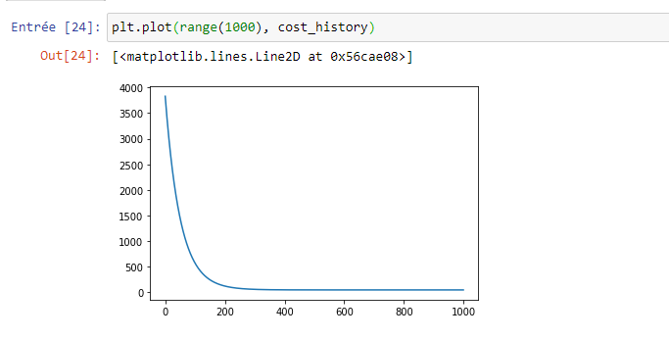
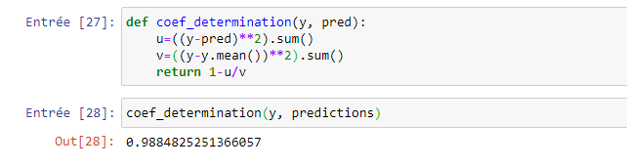
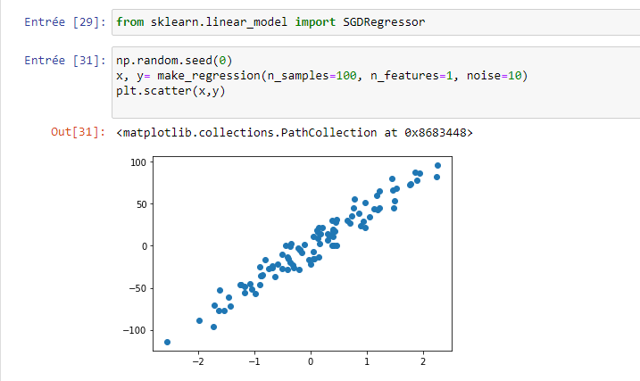
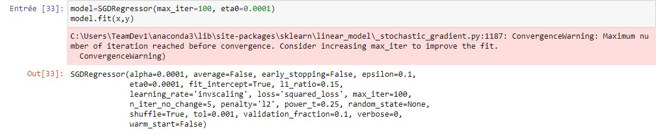
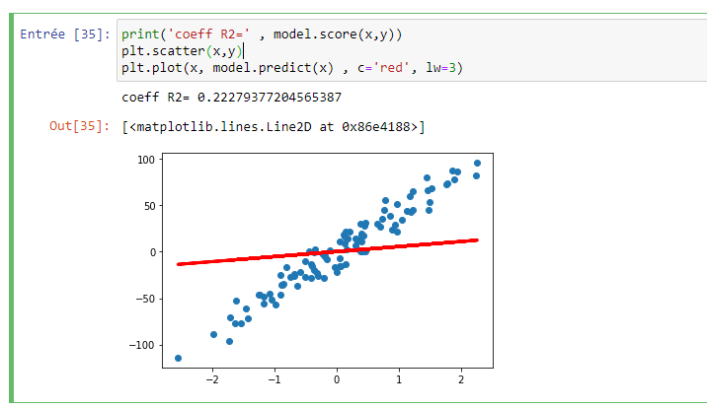
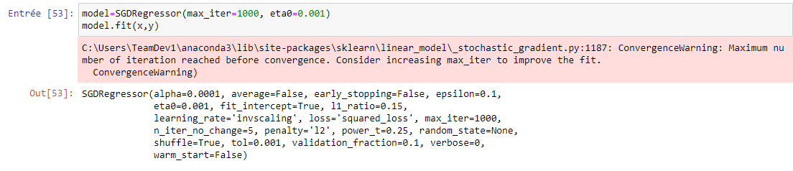
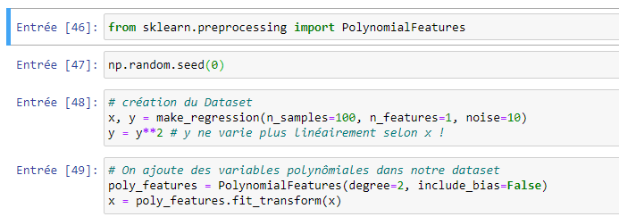
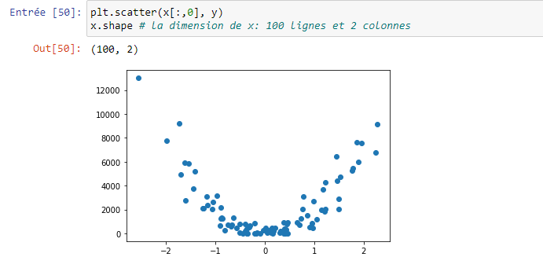
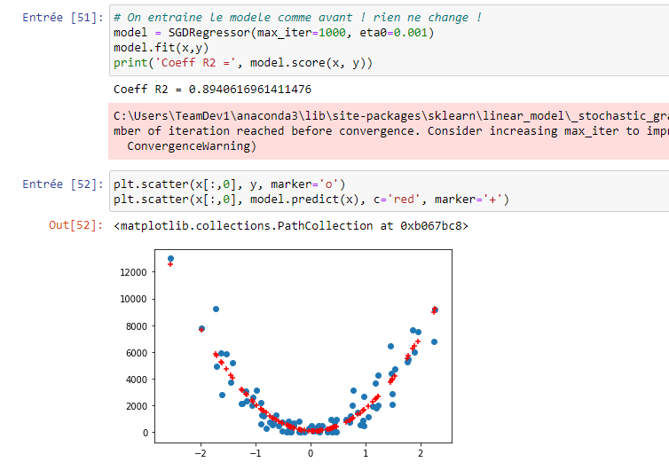

- Logistic Regression & Classification Algorithms:
- Classification Problems:
In the first chapter we have talked about the classification problem that has as a goal to classify the email as a spam or no-spam, in this case the dataset contains a variable target y which could have two values 0 or 1.
If y=0 email not spam
If y=1 email spam
A classification problem is when the output variable is a category, such as “red” or “blue” or “disease” and “no disease”. A classification model attempts to draw some conclusion from observed values. Given one or more inputs a classification model will try to predict the value of one or more outcomes.
For the problem like this we add a decision border to the model which allows us to classify an email in class 0 or class 1.

- The logistic Regression Model:
For the binary classification problem, the linear model f=X.Ɵ is not compatible as the figure bellow shows:
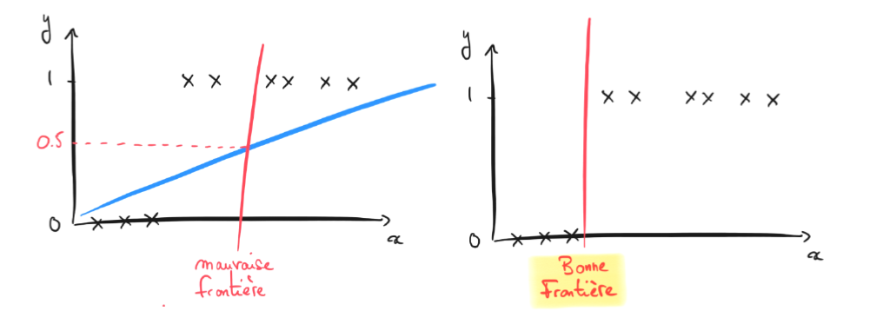
So basically we need to develop a new function for the problems of binary classification, it is the logistic function (also called function sigmoid or simply sigma 𝝈). This function has the particularity to always be included in 0 and 1.
It‘s a binomial regression model is used to model the probability of a certain class or event existing such as pass/fail, win/lose, healthy/sick… the logistic regression is named for the function used at the core of the method; the logistic Function.
To paste the logistic function on a Dataset (𝑿, 𝒚) we pass the matrix product 𝑿. 𝜽 which gives us the Logistic Model Regression:
𝝈 (X.Ɵ) = 1/1+e^{_X.Ɵ}
Based on this function we can use the decision border, Typically, we define a threshold at 0.5 like this:
𝒚=𝟎 if 𝝈(𝑿.𝜽)<𝟎.𝟓
𝒚=𝟏 if 𝝈(𝑿.𝜽)≥𝟎.𝟓
- The logistic Function:
Linear regression gives us a convex curve as result of the function J(Ɵ)=1/2m ∑ (X.Ɵ – y)² this descent gradient it got just one minima. But for the logistic model it doesn’t give the same result cause the curve blocks at the first minima without finding the global one.
So basically we need to develop a new cost function specifically for the logistic regression. Then we use the logarithm function for transform the sigma function into a convex function by separating the cases where 𝑦 = 1 of the cases where 𝑦 = 0.
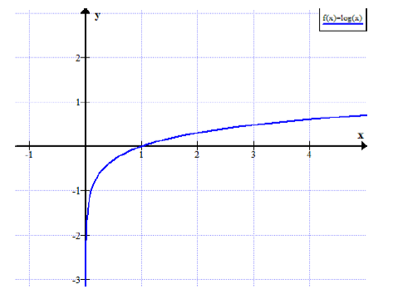
If cost function with the y=1 the cost function will be:
J(Ɵ)= -log (𝝈(𝑿. 𝜽))
If our model predicts 𝜎 (𝑥) = 0 while 𝑦 = 1, we must penalize the machine by a big mistake (a big cost). The logarithm function allows to draw this curve with a convex property, which will push the Gradient Descent to find the parameters 𝜽 for a cost which tends to 0.
If the cost function with y=0 then then cost function will be
𝑱(𝜽)= − 𝐥𝐨𝐠 (𝟏−𝝈(𝑿.𝜽))
If our model predicts 𝜎 (𝑥) = 1 while 𝑦 = 0, on must penalize the machine by a big error (a big cost). This time - 𝐥𝐨𝐠 (𝟏 - 𝟎) gives the same curve, inverted on the vertical axis.
Complete Cost function will be:
To write the Cost Function in a single equation, use the trick to separate the cases 𝑦 = 0 𝑒𝑡
𝑦 = 1 with a cancellation:
𝑱(𝜽)= − 𝟏𝒎 Σ𝒚×𝐥𝐨𝐠( 𝝈(𝑿.𝜽))+(𝟏−𝒚)×𝐥𝐨𝐠(𝟏− 𝝈(𝑿.𝜽))

In case y=0 it remains:
𝐽(𝜃)= − 1𝑚 Σ0×log(𝜎(𝑋.𝜃))+𝟏×𝐥𝐨𝐠(𝟏−𝝈(𝑿.𝜽))
In case y=1 it remains:
𝐽(𝜃)= − 1𝑚 Σ𝟏×𝐥𝐨𝐠(𝝈(𝑿.𝜽))+0×log(1−𝜎(𝑋.𝜃))

Gradient Descent for Logistic Regression
For the logistic regression we have to applicate the descent gradient in the same way as the linear regression beside the derivative of the Cost Function is the same too so we got:

𝐺𝑟𝑎𝑑𝑖𝑒𝑛𝑡: 𝝏 𝑱(𝜽)𝝏 𝜽= 𝟏𝒎Σ( 𝝈(𝑿.𝜽)−𝒚).𝑿
𝐺𝑟𝑎𝑑𝑖𝑒𝑛𝑡 𝐷𝑒𝑠𝑐𝑒𝑛𝑡: 𝜽= 𝜽− 𝜶×𝝏 𝑱(𝜽)𝝏 𝜽
So the logistic regression got:
𝑴𝒐𝒅e𝒍: 𝜎(𝑋.𝜃) = 11+𝑒−𝑋.𝜃
Cost 𝑭u𝒏𝒄𝒕𝒊𝒐𝒏: 𝐽(𝜃)= − 1𝑚 Σ𝑦×log ( 𝜎(𝑋.𝜃))+(1−𝑦)×log(1− 𝜎(𝑋.𝜃))
𝑮𝒓𝒂𝒅𝒊𝒆𝒏𝒕: 𝜕 𝐽(𝜃)𝜕 𝜃= 1𝑚 𝑋𝑇.( 𝜎(𝑋.𝜃)−𝑦)
𝑮𝒓𝒂𝒅𝒊𝒆𝒏𝒕 𝑫𝒆𝒔𝒄𝒆𝒏𝒕: 𝜃= 𝜃− 𝛼×𝜕 𝐽(𝜃)𝜕 𝜃

- Develop a binary classification program in Jupyter:
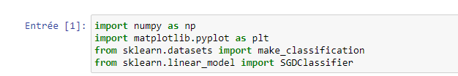
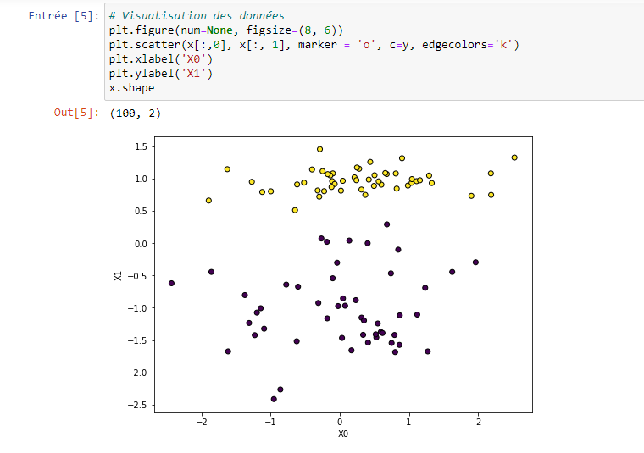
Create a model using the SGDClassifier:
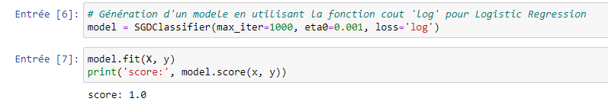
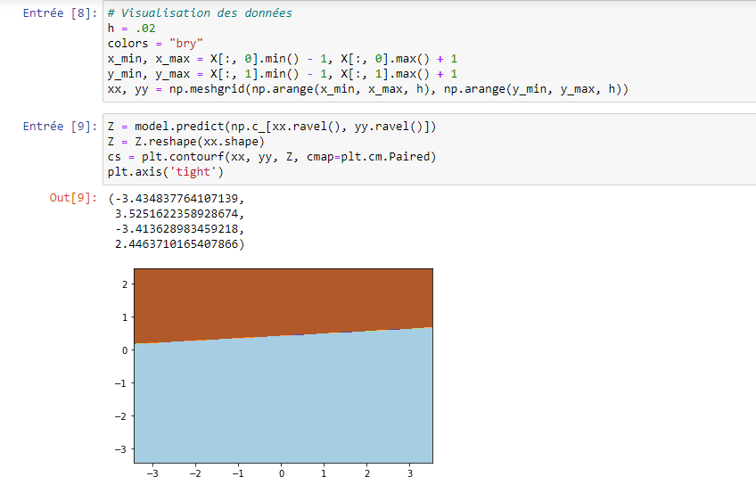
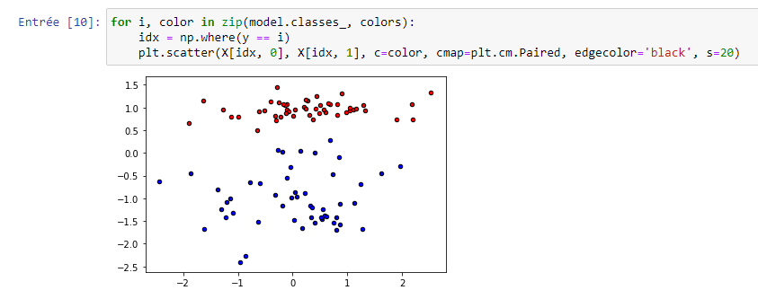

- The Nearest Neighbor Algorithm:
- Computer vision with K-NN in Jupyter:
- Neural Networks:

